Ask a scientist worksheet

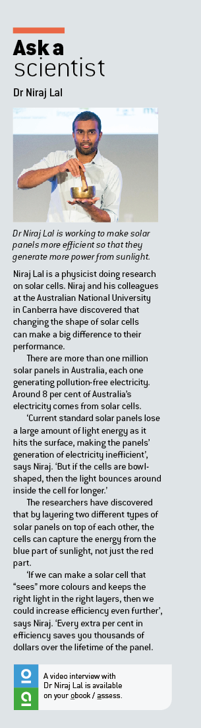3.7 Solar cells transform the Sun’s light energy into electrical energy

Pages 54–55

Dr Niraj Lal – physicist

1 What kinds of things are physicists currently working on? Niraj names many. How many can you remember? Once you have created a list, share it with the person next to you and add in any that you didn’t have.

_____________________________________________________________

_____________________________________________________________

_____________________________________________________________

_____________________________________________________________

_____________________________________________________________

_____________________________________________________________

2 Create a flow diagram (with three stages) showing the energy transformations that take place from a solar cell all the way to an electric water heater in your house.

3 What are some of the many benefits of using solar panels?

4 What inventions and new productions can you think of that might use solar power?

5 What is it about Australia specifically that makes it so well suited to solar power?

6 What percentage of the world does not have access to electricity? How many people does that amount to?

7 Describe some ways that not having electricity would affect your life.